课程名称＿数据结构 实验名称＿＿11＿＿＿＿＿ 实验日期＿2019.4＿＿＿＿＿＿
班 级＿计科1805＿＿ 姓 名＿吕思颖＿＿＿ 学号＿1033180511＿ 仪器编号＿＿＿＿＿＿
实验报告要求 1.实验目的 2.实验要求 3.实验步骤 4.程序清单 5.运行情况 6.流程图 7.实验体会
实验目的：
⑴ 熟悉赫夫曼树的定义和基本操
⑵ 掌握赫夫曼树的存储结构设计与赫夫曼编码的实现

实验内容：
实验任务与要求：
⑴ 定义赫夫曼树和赫夫曼编码的存储表示
⑵ 基于所设计的存储结构实现赫夫曼编码
⑶ 编写主函数对所实现的赫夫曼编码进行测试

程序清单：
1.
#include <stdio.h>
#include <stdlib.h>
#include <string.h>
typedef struct
{
unsigned int weight;
unsigned int parent, lchild, rchild;
}HTNode, *HuffmanTree; //动态分配数组存储赫夫曼树
typedef char **HuffmanCode;//动态分配数组存储赫夫曼编码表
//求编码
void Select(HuffmanTree &HT, int u, int &s1, int &s2)
{
int j;
j = 1;
while (j < u&&HT[j].parent != 0)
j++;
s1 = j;
while (j <= u)
{
if (HT[j].parent == 0 && HT[j].weight < HT[s1].weight) s1 = j; //求weight 最小并记为s1
j++;
}
HT[s1].parent = u + 1;
j = 1;
while (j <= u && HT[j].parent != 0)
j++;
s2 = j;
while (j <= u)
{
if (HT[j].parent == 0 && HT[j].weight < HT[s2].weight) s2 = j;
j++;
}
if (s1 > s2)
{
j = s1; s1 = s2; s2 = j;
}
}
void HuffmanCoding(HuffmanTree &HT, HuffmanCode &HC, int *w, int n)
{
//w存放n个字符的权值（均>0),构造哈夫曼树HT,并求出n个字符的赫夫曼编码HC
if (n <= 1) return;
int m = 2 * n - 1, i, j, s1, s2;
HT = (HuffmanTree)malloc((m + 1) * sizeof(HTNode)); //从1开始
for (i = 1; i <= n; ++i)
{
//p的指针加一
HT[i].weight = w[i - 1];
HT[i].parent = 0;
HT[i].lchild = 0;
HT[i].rchild = 0;
}//初始化每个叶子结点
for (i = n + 1; i <= m; ++i)
{
HT[i].weight = 0;
HT[i].parent = 0;
HT[i].lchild = 0;
HT[i].rchild = 0;
}//初始化剩下的结点
printf("\n赫夫曼树的构造过程如下所示:\n");
printf("HT初态:\n 结点 weight parent lchild rchild");
for (i = 1; i <= m; i++)
printf("\n %4d%8d%8d%8d%8d", i, HT[i].weight, HT[i].parent, HT[i].lchild, HT[i].rchild);
for (i = n + 1; i <= m; ++i)
{
//建赫夫曼树
//在HT[1..i-1]选择parent为0且weight最小的两个结点，其序号分别为s1和s2。
Select(HT, i - 1, s1, s2);
HT[s1].parent = i; HT[s2].parent = i;
HT[i].lchild = s1; HT[i].rchild = s2;
HT[i].weight = HT[s1].weight + HT[s2].weight;
printf("\nselect: s1=%d,s2=%d\n", s1, s2);
printf("结点 weight parent lchild rchild");
for (j = 1; j <= i; j++)
printf("\n%4d%8d%8d%8d%8d", j, HT[j].weight, HT[j].parent, HT[j].lchild, HT[j].rchild);
}
printf("\n");
//---从叶子到根逆向求每个字符的赫夫曼编码---
HC = (HuffmanCode)malloc((n + 1) * sizeof(char *));
char *cd; unsigned int c, f;
int start;
cd = (char *)malloc(n * sizeof(char));
cd[n - 1] = '\0';
for (i = 1; i <= n; ++i)
{
start = n - 1;
for (c = i, f = HT[i].parent; f != 0; c = f, f = HT[f].parent)//从叶子到根逆向求编码
if (HT[f].lchild == c) cd[--start] = '0';
else cd[--start] = '1';
HC[i] = (char *)malloc((n - start) * sizeof(char));
strcpy(HC[i], &cd[start]);
}
free(cd);
printf("输出个结点的赫夫曼编码:\n");
for (i = 1; i <= n; i++)
printf("%2d %s\n", i, HC[i]);
}//HuffmanCoding
int main()
{
int w[] = { 5,29,7,8,14,23,3,11 }, n = 8;
HuffmanTree HT;
HuffmanCode HC;
HuffmanCoding(HT, HC, w, n);
}

2.
#include <stdio.h>
#include <stdlib.h>
#include <string.h>
typedef struct {
unsigned int weight;
unsigned int parent,lchild,rchild;
}HTNode,*HuffmanTree; //动态分配数组存储赫夫曼树
typedef char **HuffmanCode;//动态分配数组存储赫夫曼编码表
//求编码
void Select(HuffmanTree &HT,int u,int &s1,int &s2){
int j;
j=1;
while (j<u&&HT[j].parent!=0) j++;
s1=j;
while (j<=u){
if(HT[j].parent ==0&& HT[j].weight<HT[s1].weight) s1=j; //求weight 最小并记为s1
j++;
}
HT[s1].parent =u+1;
j=1;
while(j<=u && HT[j].parent!=0) j++;
s2=j;
while(j<=u){
if(HT[j].parent==0&&HT[j].weight<HT[s2].weight) s2=j;
j++;
}
if(s1>s2){
j=s1; s1=s2; s2=j;
}
}
void HuffmanCoding(HuffmanTree &HT,HuffmanCode &HC,int *w,int n){
//w存放n个字符的权值（均>0),构造哈夫曼树HT,并求出n个字符的赫夫曼编码HC
if(n<=1) return;
int m=2*n-1,i,j,s1,s2;
HT=(HuffmanTree)malloc((m+1)*sizeof(HTNode)); //从1开始
for(i=1;i<=n;++i){//p的指针加一
HT[i].weight=w[i-1];
HT[i].parent=0;
HT[i].lchild=0;
HT[i].rchild=0;
}//初始化每个叶子结点
for (i=n+1;i<=m;++i){
HT[i].weight=0;
HT[i].parent=0;
HT[i].lchild=0;
HT[i].rchild=0;
}//初始化剩下的结点
printf("\n赫夫曼树的构造过程如下所示:\n");
printf("HT初态:\n 结点 weight parent lchild rchild");
for(i=1;i<=m;i++)
printf("\n %4d%8d%8d%8d%8d",i,HT[i].weight,HT[i].parent,HT[i].lchild,HT[i].rchild);
for (i=n+1; i<=m; ++i){//建赫夫曼树
//在HT[1..i-1]选择parent为0且weight最小的两个结点，其序号分别为s1和s2。
Select(HT,i-1,s1,s2);
HT[s1].parent=i; HT[s2].parent=i;
HT[i].lchild=s1;HT[i].rchild=s2;
HT[i].weight=HT[s1].weight+HT[s2].weight;
printf("\nselect: s1=%d,s2=%d\n",s1,s2);
printf("结点 weight parent lchild rchild");
for(j=1;j<=i;j++)
printf("\n%4d%8d%8d%8d%8d",j,HT[j].weight,HT[j].parent,HT[j].lchild,HT[j].rchild);
}
printf("\n");
//---从叶子到根逆向求每个字符的赫夫曼编码---
HC=(HuffmanCode)malloc((n+1)*sizeof(char *));
int p=m,cdlen=0;
char *cd;
cd=(char *)malloc(n*sizeof(char));
for(i=1;i<=m;i++)HT[i].weight=0;
while(p)
{
if(HT[p].weight==0)
{
HT[p].weight=1;
if(HT[p].lchild!=0)
{
p=HT[p].lchild;cd[cdlen++]='0';
}else if(HT[p].rchild==0)
{
HC[p]=(char *)malloc((cdlen+1)*sizeof(char));
cd[cdlen]='\0';strcpy(HC[p],cd);
}
}else if(HT[p].weight==1)
{
HT[p].weight=2;
if(HT[p].rchild!=0)
{
p=HT[p].rchild;
cd[cdlen++]='1';
}
}else
{
HT[p].weight=0;p=HT[p].parent;
--cdlen;
}
}free(cd);
printf("输出各结点的赫夫曼编码：\n");
for(i=1;i<=n;i++)
printf("%2d %2d %s\n",i,w[i-1],HC[i]);
}//HuffmanCoding
int main(){
int w[]={5,29,7,8,14,23,3,11}, n=8;
HuffmanTree HT;
HuffmanCode HC;
HuffmanCoding(HT,HC,w,n);
}
运行情况：
1.
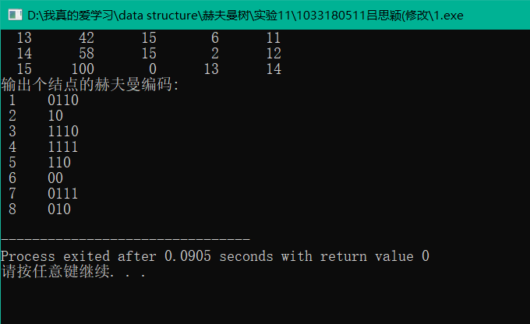
2.
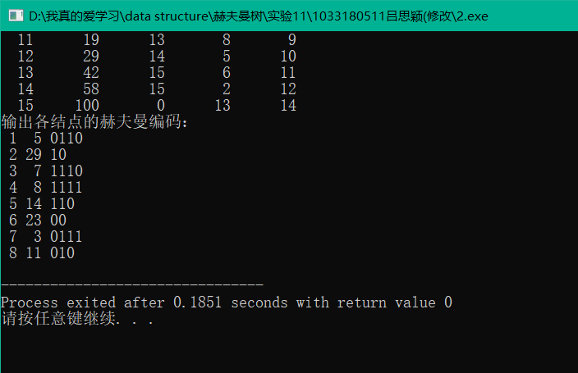
实验体会：
不能理解select函数
教师评价 | 优 |  | 良 |  | 中 |  | 及格 |  | 不及  格 |  | 教师签名 |  | 日期
江南大学物联网工程学院实验报告

